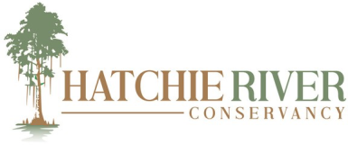

the Hatchie River and its watershed.”

TO:
Haywood County Commission
Haywood County Mayor
Haywood County Attorney

DATE: June 1, 2026

Regarding maintenance of mural art, Highway 76 at Hatchie State Scenic River, Haywood County TN

In partnership with Ford Motor Company/Blue Oval City, Hatchie River Conservancy will oversee the placement and maintenance of mural art on the Highway 76 bridge at Hatchie River. The placement of the art will be on the side of the bridge above the parking area. Expected maintenance will include occasional cleaning to remove dust, etc. The location of the art is well above the highest probable flooding predictions of the river. Possible maintenance may also include vandalism of the art (graffiti or spray paint). The artist, Mary Spelling, will paint a final coat on the art that allows for removal of graffiti without damaging the art work. If vandalism should occur, Hatchie River Conservancy and the artist will remove it and return the art to the highest possible quality.

Bob Ford, Executive Director
Hatchie River Conservancy

2 99 808 Hatchie Street Brownsville TN
