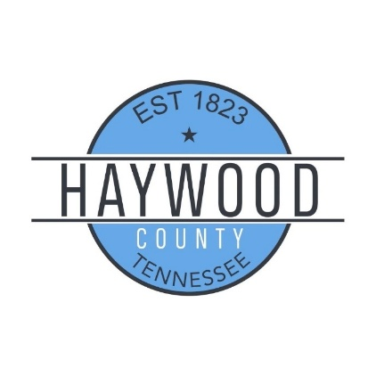
FY25–26 Budget Summary
Prepared for County Commission | Haywood County Tennessee

Budget Overview
The proposed FY25–26 budget reflects careful planning amid cost pressures and a strategic drawdown of fund balance to maintain critical services.
- All departmental budgets have been reviewed and approved by the Budget Committee, except:
  - Central Dispatch (54900): Remains at FY24–25 amounts pending updated figures from the City.

Cost Pressures & Increases
- State Retirement Rate increased from 10.34% to 10.83%
  - Total County General Impact: ~$49,000
- Carryforward Grant Spending from FY24–25:
  - Fund 101: ~$885,000
  - Fund 171: ~$4.38 million
  - These inflate FY25–26 expenditures but are not new obligations.
- A 2.5% cost of living raise was calculated for all non-elected officials
  - Total County General Impact: ~$251,000

Shared Emergency Services Funding
- Fund 101 makes quarterly transfers to Fund 357:
  - Civil Defense: County covers 25% (TEMA pays 50%, City covers 25%)
  - Rescue Squad: 50/50 split between County and City

Megasite Adjustment
- Megasite-related costs have been removed from the Sheriff’s Department budget for FY25–26, improving departmental accuracy and transparency.

City Fire Adjustment
- The annual $875,000 payment to the City for fire protection services has been removed from the FY25-26 County General budget.

Fund Balance Forecast – County General Fund 101
- FY24–25 Ending Projection:
  - Deficit: ~$2.2 million
  - Ending Fund Balance: ~$12 million
- FY25–26 Projection:
  - Deficit: ~$2.3 million (including carryforward)
  - Ending Fund Balance: ~$8.8 million
Fund Balance Forecast – Drug Control Fund 122
- FY24–25 Ending Projection:
  - Surplus: ~$40,000
  - Ending Fund Balance: ~$142,000
- FY25–26 Projection:
  - Surplus: ~$14,000
  - Ending Fund Balance: ~$156,000

Fund Balance Forecast – Highway/Public Works Fund 131
- FY24–25 Ending Projection:
  - Deficit: ~$2 million
  - Ending Fund Balance: ~$2.9 million
- FY25–26 Projection:
  - Deficit: ~$2 million
  - Ending Fund Balance: ~$841,000
Fund Balance Forecast – General Purpose School Fund 141
- FY24–25 Ending Projection:
  - Deficit: ~$3.1 million
  - Ending Fund Balance: ~$7.26 million
- FY25–26 Projection:
  - Deficit: ~$5.5 million
  - Ending Fund Balance: ~$1.7 million
Fund Balance Forecast – Central Cafeteria Fund 143
- FY24–25 Ending Projection:
  - Deficit: ~$448,000
  - Ending Fund Balance: ~$1 million
- FY25–26 Projection:
  - Deficit: ~$457,000
  - Ending Fund Balance: ~$622,000
Fund Balance Forecast – General Debt Service Fund 151
- FY24–25 Ending Projection:
  - Surplus: ~$1.1 million
  - Ending Fund Balance: ~$5.1 million
- FY25–26 Projection:
  - Surplus: ~$837,000
  - Ending Fund Balance: ~$5.96 million

Fund Balance Forecast – General Capital Projects Fund 171
- FY24–25 Ending Projection:
  - Surplus: ~$2.89 million
  - Ending Fund Balance: ~$7.19 million
- FY25–26 Projection:
  - Surplus: ~$1,000 (including carryforward)
  - Ending Fund Balance: ~$2.9 million
Fund Balance Forecast – Solid Waste/Landfill Fund 207
- FY24–25 Ending Projection:
  - Deficit: ~$344,000
  - Ending Fund Balance: ~$1.3 million
- FY25–26 Projection:
  - Surplus: ~$30,000
  - Ending Fund Balance: ~$1.36 million
Fund Balance Forecast – Joint Venture Fund 357
- FY24–25 Ending Projection:
  - Surplus: ~$49,000
  - Ending Fund Balance: ~$178,000
- FY25–26 Projection:
  - Deficit: ~$3,000
  - Ending Fund Balance: ~$175,000

Summary
This budget is the result of collaborative planning and reflects realistic assumptions. While short-term fund balance usage is necessary, long-term sustainability for our county remains a priority.

