January 16, 2025

**NOTIFICATION OF AUDIT RELEASE**

Haywood County Official:

The Division of Local Government Audit will release the Annual Financial Report of Haywood County, Tennessee, for the year ended June 30, 2024, on January 21, 2025. A PDF file containing this report has been provided to the county mayor, chief administrative highway officer, director of schools, and the school department’s finance officer. Interested officials and citizens may obtain a copy of the PDF file from one of the officials noted above. Also, this report will be available for inspection at <https://comptroller.tn.gov/office-functions/la.html>.

Auditors are available to meet with the county’s Audit Committee to discuss all aspects of the audit upon the request of that committee. Requests should be made to the West Tennessee audit manager for available dates and times:

West Tennessee Audit Manager – Lee Ann West 731-421-7473 or lee.ann.west@cot.tn.gov

Included with this notice is a copy of the Summary of Audit Findings.

Very truly yours,

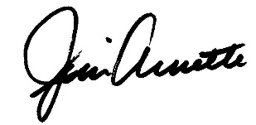

James R. Arnette, Director

**Media contact:**

John Dunn, Director of Communications, 615.401.7755 or [john.dunn@cot.tn.gov](mailto:john.dunn@cot.tn.gov)